1.Pre-Process Missing Values
Preprocess(tab)
filter(choose)>unsupervised>attribute>ReplaceMissingValues
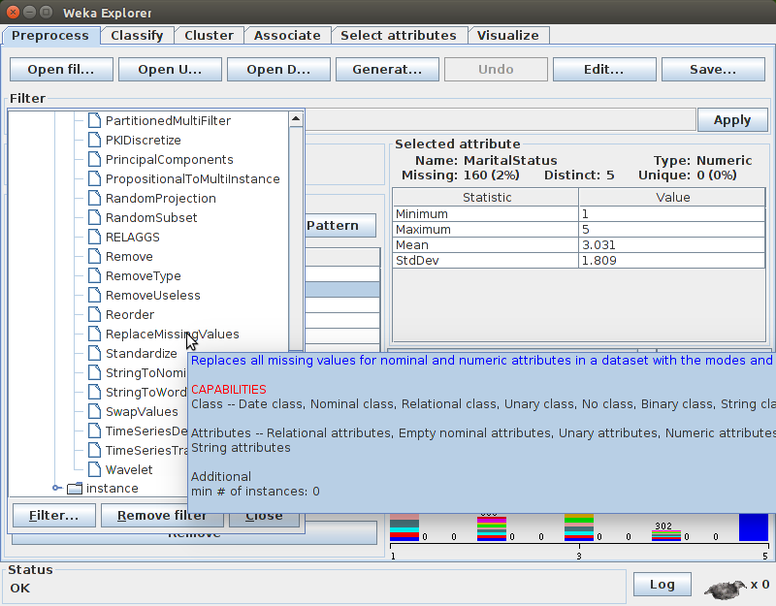
supervised>attribute>PLSfilter(cannot handle multi-valued nominal class)
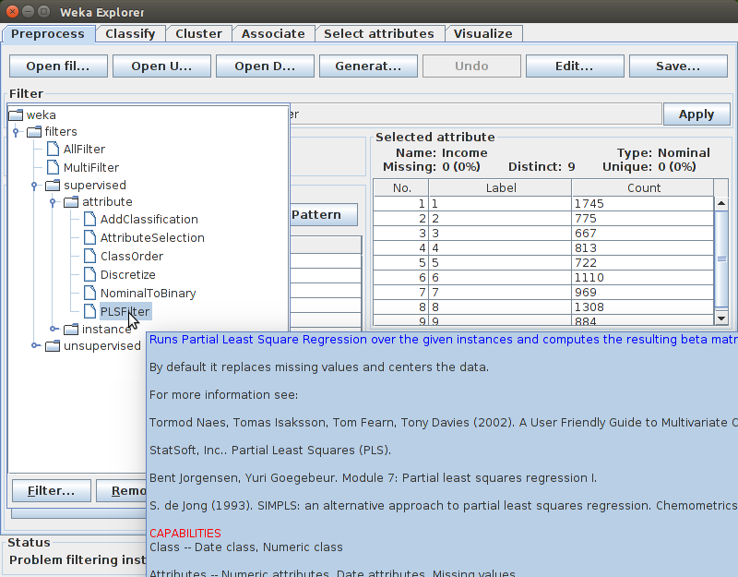

2.Attribute Filter Option
Select Attributes(tab)
Attribute Evaluator:CfsSubsetEval Method:BestFirst 5 selected in 14
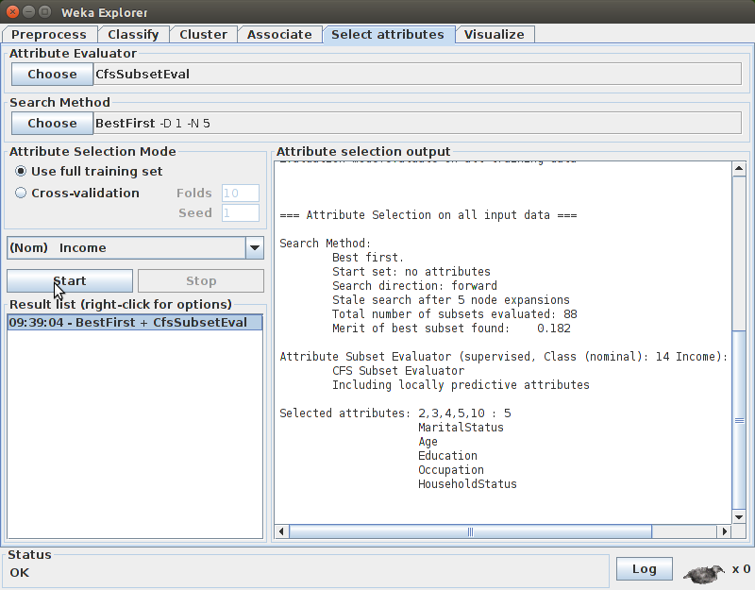
Attribute Evaluator:FilteredSubsetEval Method:GreedyStepWise 5 selected in 14
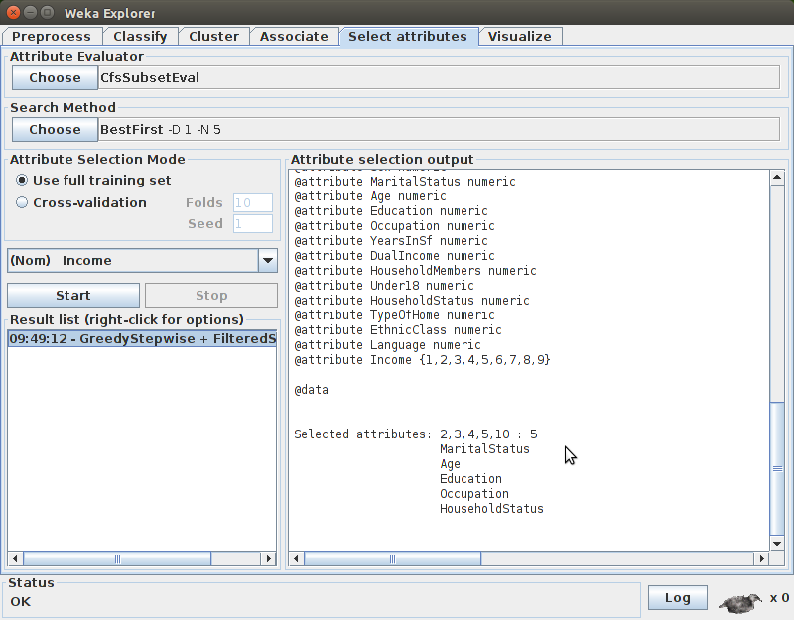

3.Discretization
Preprocess(tab)
Supervised>attribute>Discretize
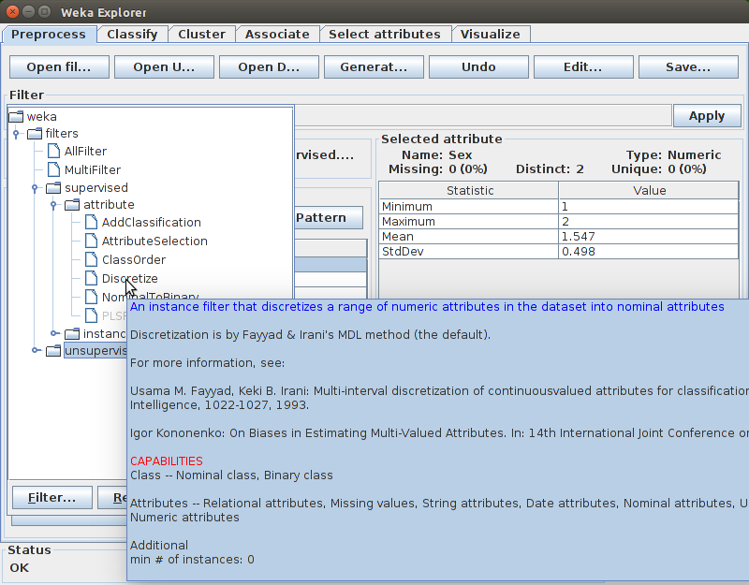

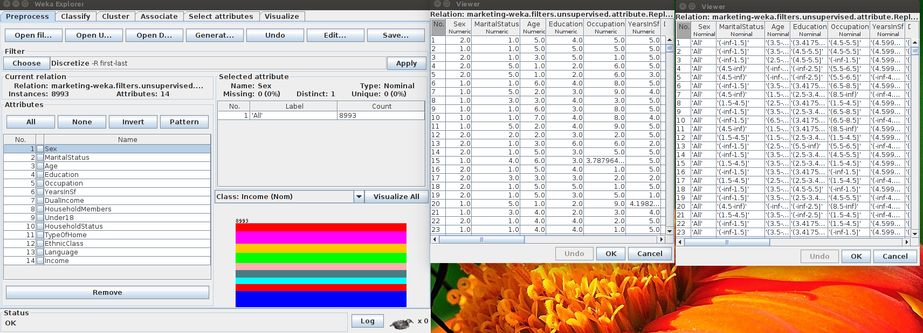
Unsupervised>attribute>Discretize
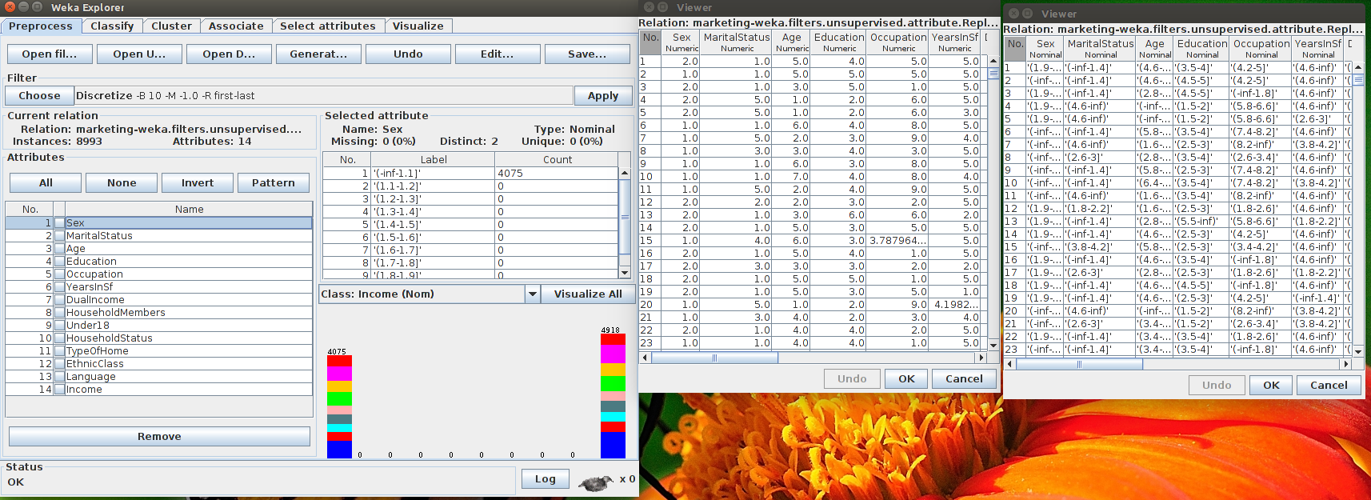

4.Visualize
Visualize all(in Preprocess tab)
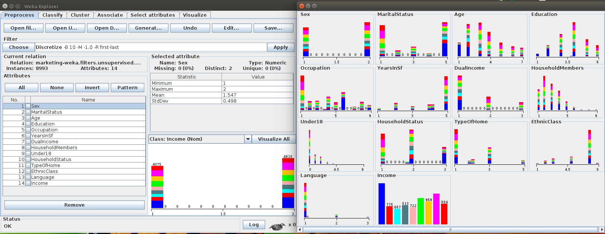
Visualize(tab)
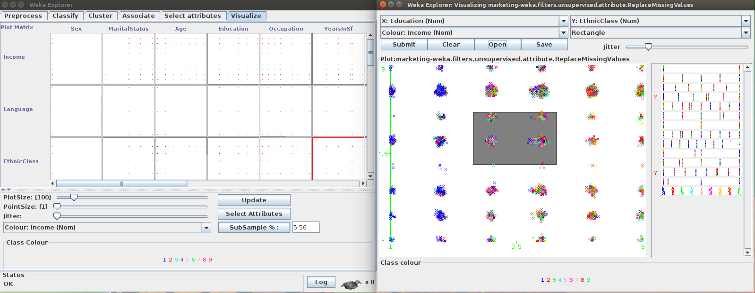
(LEFT img)A matrix of all attributes against alla ttriutes is provided(with default coloring with CLASS attribute), options to play with the visualization are provided at the bottom
(RIGHT img)Selecting any section gives a closer look onto the data, with a flexible options, like hanging X, Y axes, selecting a region(from Select Instance-(here used Rectangle))

5.Data Transformation
Preprocess(tab)
Unsupervised>attribute has many options for data transformation
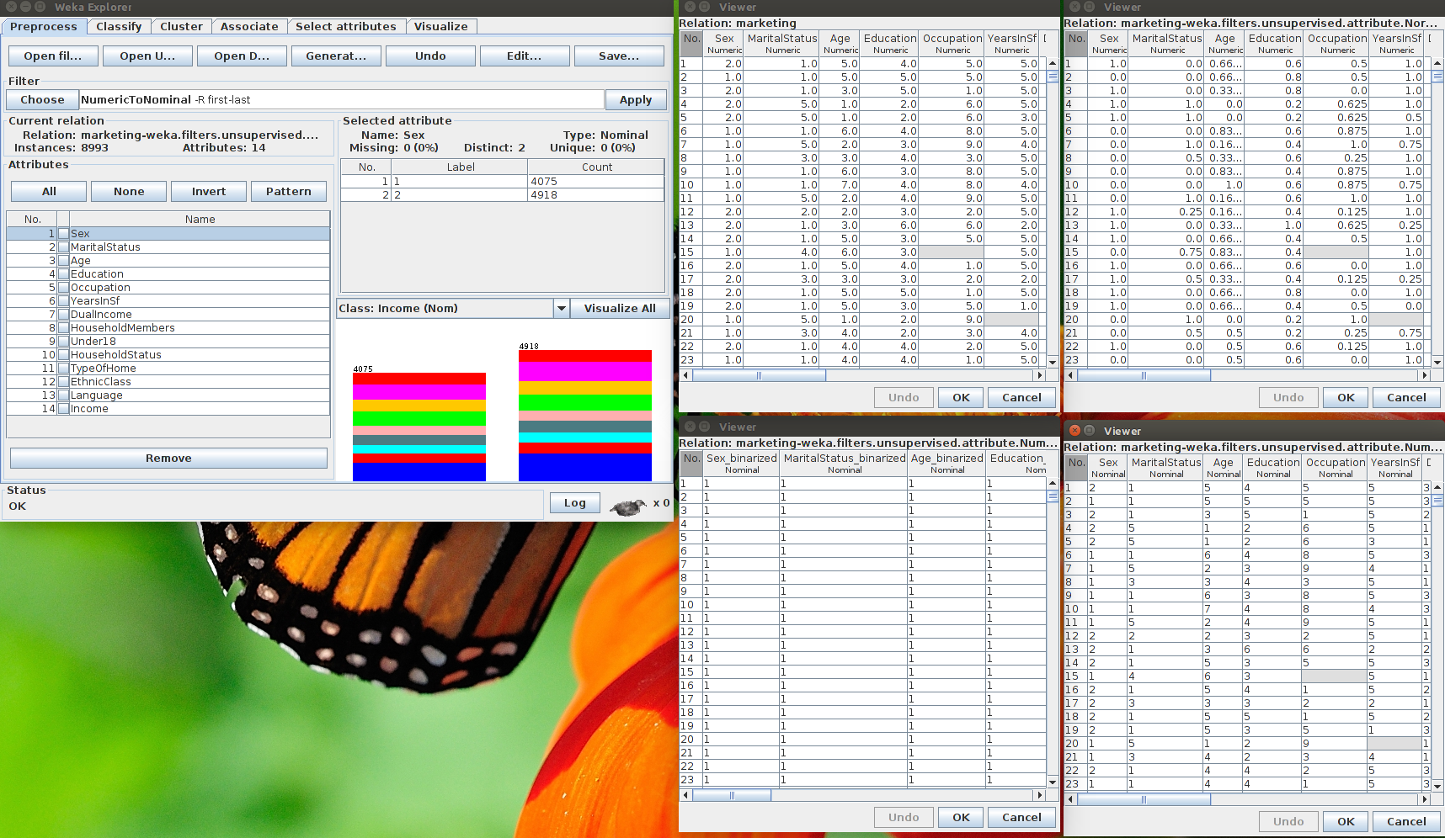
1.Original
2.Normalize
3.NumericToBinary
4.NumericToNominal

6.Attribute Selection
Preprocess(tab)
supervised.attribute.AttributeSelection
Default Evaluator:CfsSubsetEval method:BestFit
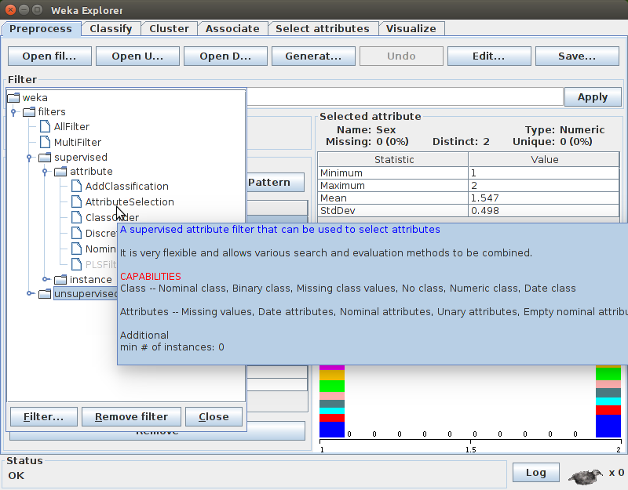
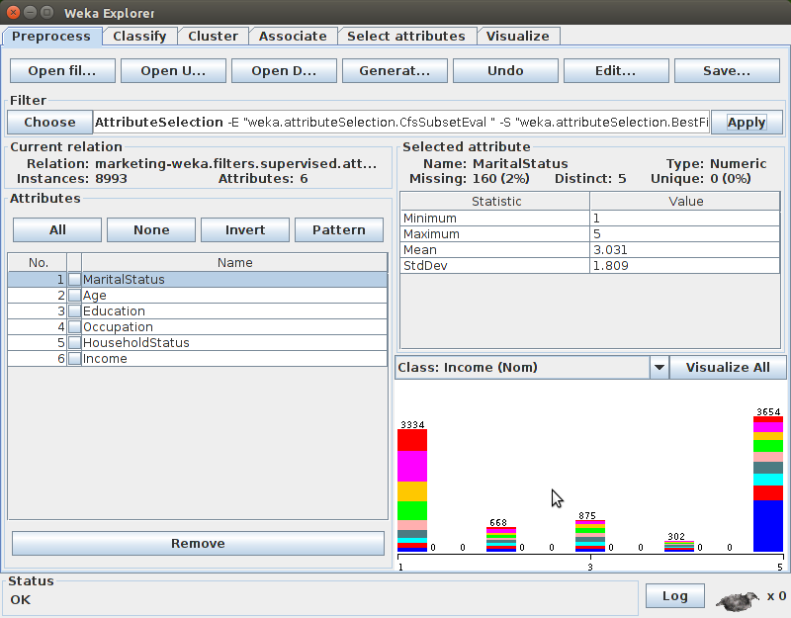

Final set of attributes have only 6 in number

